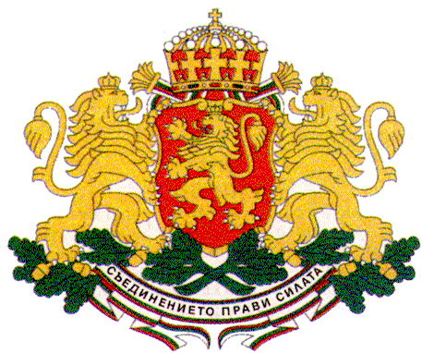 | PERMANENT MISSION OF THE REPUBLIC OF  BULGARIA  TO THE UNITED NATIONS

11 East 84th Street, New York, NY 10028, Tel: (212) 737 4790, Fax: (212) 472 9865, e-mail: bulgaria@un.int

High-level SDG Action Event on Education
New York, 28 June 2017, UNHQs

Education for Sustainable Development and Education for Global Citizenship

H.E. Mr. Georgi Panayotov, Ambassador, Permanent Representative of Bulgaria to the UN

Mr. Moderator,
Education is a fundamental human right and is crucial for the realization of all other human rights.
Education is a powerful tool for empowerment and a key element to achieving lasting peace and sustainable development.
The 2030 Agenda for Sustainable Development reaffirms the strong commitment to ensuring inclusive and quality education for all.
Bulgaria believes that education is central to achieving sustainable development and has been actively promoting a rights-based approach in the implementation of the 2030 Agenda ensuring the right to education for all without discrimination of any kind.
Bulgaria has established the necessary legal framework to guarantee the right to quality education for all with a special focus on those who are most vulnerable and disadvantaged, especially children and youth with disabilities. Inclusive education is a key priority for the Government of Bulgaria.
As co-chair of the Group of Friends of Children and the SDGs Bulgaria has been strongly advocating for integrating children’s rights in the 2030 Agenda and for engaging children in the implementation of the Agenda by acquainting them with the Sustainable Development Goals in schools at national level.
Since 2015 Bulgaria has been actively participating in the World’s Largest Lesson Global Initiative aimed at teaching children about the SDGs. Up to date more than 40 000 students in over 1 500 schools in Bulgaria have learned about the SDGs.
Bulgaria believes that this initiative, which has already mobilized more than 500 million girls and boys in over 160 countries can become a powerful movement to engage children in the joint effort to achieve the new goals by encouraging them to drive real change in their own lives.
In addition, many schools in Bulgaria have started their own initiatives to promote sustainable development learning and action. For example, UNESCO Associated Schools in North Bulgaria have been implementing projects related to the conservation of the biodiversity and ecosystems of the Danube River in collaboration with other European countries. The UN Association of Bulgaria in partnership with the Ministry of Education and Science and UNESCO Associated Schools is currently implementing a joint project entitled 17 steps towards sustainable development which works as an important platform to spread the knowledge of the 17 goals and engage young people in Bulgaria to implement the core principles of sustainable development in their everyday lives.
The Bulgarian Government made a step forward with the adoption of the new Pre-School and School Act in 2016 which provides for integrating sustainable development into teaching and learning. With this new legislation knowledge on sustainable development has been included as one of the 9 key competencies that children should acquire in school. The topic of sustainable development has been integrated in the curriculum throughout the whole course of education with the content being adapted for the different age groups. For example, in primary education sustainable development forms part of three curriculum subjects whereas in secondary education 11 curriculum subjects include the topic of sustainable development. Children are taught about climate change, disaster risk reduction, biodiversity, poverty reduction, sustainable consumption, and other issues of global significance. Teachers are encouraged to apply participatory teaching and learning methods that motivate and empower students to take action for sustainable development in their everyday activities thus promoting change in their own communities and beyond. Ensuring children’s active participation in projects that address global issues of social, economic and environmental nature as part of the global citizenship education consequently promotes also competencies like critical thinking, imagining future scenarios and making decisions in a collaborative way that enables them to take action and be the real agents of change for creating a more sustainable future for all.

Question:
I have shared Bulgaria’s experience as regards the right to education and the implementation of the 2030 Agenda. I would like to request the panelists for their option on how the UN could further mobilize global action for the implementation of the 2030 Agenda and for a more meaningful and active engagement of children and youth in achieving sustainable development.

Thank you, Mr. Moderator!

